SQL EXERCISES
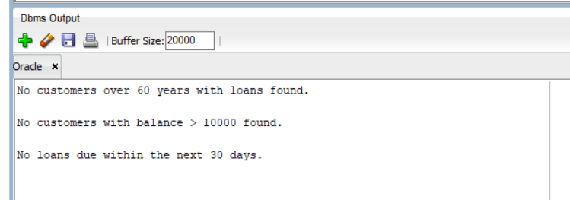
EXERCISE – 1

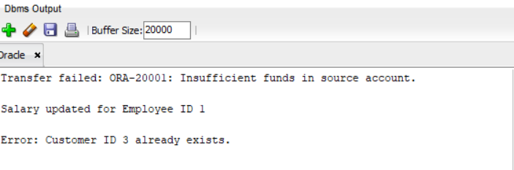
EXERCISE – 2

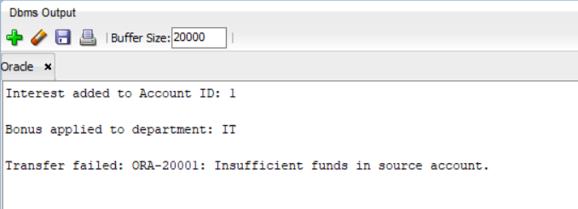
EXERCISE – 3
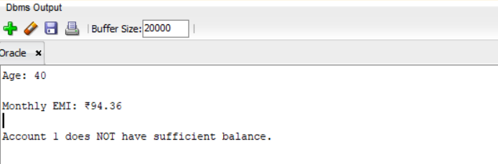
EXERCISE - 4

EXERCISE – 5
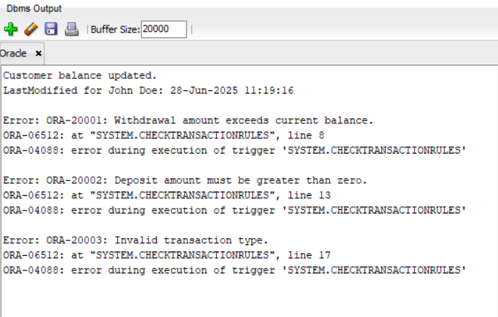

EXERCISE – 6
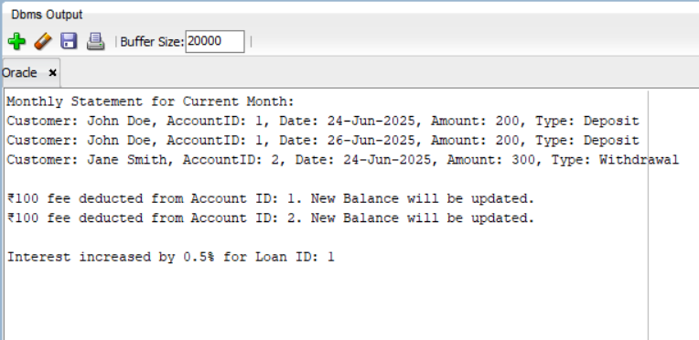

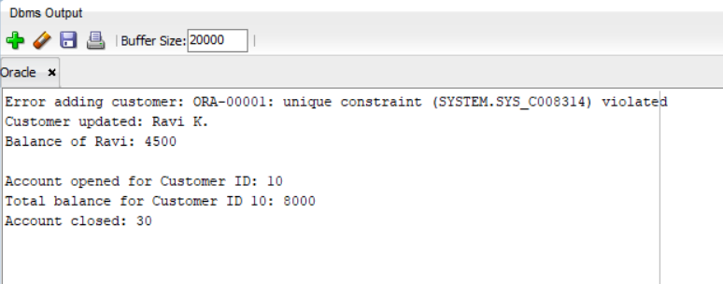
EXERCISE - 7

